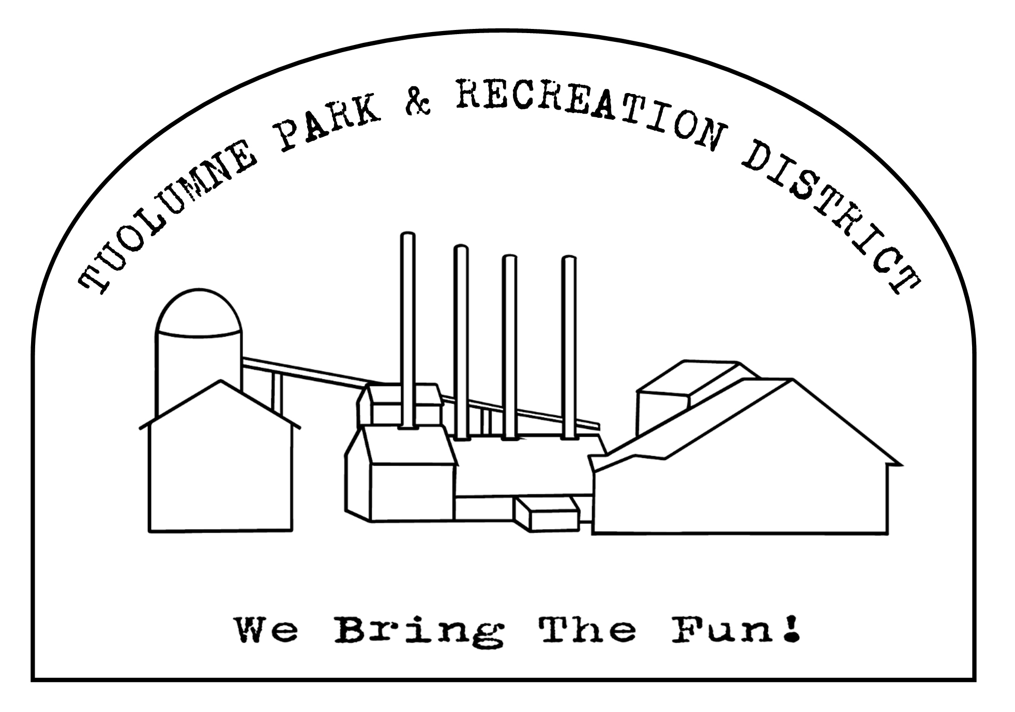
Tuolumne Park and Recreation District
18603 Pine Street

Tuolumne, California 95379 (209) 928-1214 • FAX (209) 928-1205
admin@tuolumnerecreation.com
www.tuolumnerecreation.com

AGENDA
REGULAR MEETING OF THE TPRD BOARD OF DIRECTORS
December 11, 2024– 6:00 PM
Meeting will be held at 18603 Pine Street, Tuolumne, CA 95379

1. PLEDGE OF ALLEGIANCE
- APPROVAL OF AGENDA (additions or deletions)
- Opportunity for members of the public to address the Board on any item under the subject matter of the jurisdiction of the District that is not on the agenda. Limit comments to no more than 5 minutes.
- CONSENT AGENDA: (Acted on as one item unless withdrawn by request of the Board member or a member of the public)
Items on the Consent Agenda are considered to be routine and enacted by one or more motions. Any item maybe removed for discussion and made a part of the regular agenda at the request of a member of the Board. An announcement shall be made before action is taken on any item, that the public may address an item on said Consent Agenda.
  - Approval of Regular Meeting Minutes – November 2024
  - Approval of Routine Bills
  - Approval of November 2024 Warrant

- CORRESPONDENCE –Received since the last monthly meeting.

6. SAFETY MEETING
7. REPORTS:

7.1 District Manager
7.2 Maintenance Report
7.3 Office/Events
7.4 Financial
7.5 Projects

8. DISCUSSION/ACTION ITEMS
8.1 Consideration and Installation of New Board Member and Board Committees
8.2 Consideration of Amended County Contract Renewal
8.3 Consideration of Purchasing New District Vehicle
8.4 Consideration and Update of Bank Change

9. ITEMS TO DISCUSS FOR NEXT MEETING
10. ADJOURNMENT

In accordance with the Americans with Disabilities Act, if you need special assistance (i.e. auxiliary aids or services) in order to participate in this public meeting, please contact Office Staff of Tuolumne Park and Recreation District (209-928-1214). Notification 48 hours prior to the start of the meeting will enable Office Staff to make reasonable accommodations to ensure accessibility to this public meeting.

At the discretion of the Board, all items appearing on the agenda whether or not expressly listed for action, may be deliberated and may be subject to action by the Board. Late agenda material can be inspected in the TPRD office at 18603 Pine Street, Tuolumne, CA
Note: Please notify the District Office Staff at (209) 928-1214 at least 7 days in advance of the meeting with additional items. The Board meets on the second Wednesday (except in June, July, and August where they meet on Tuesdays) of each month at 6:00pm at the TPRD office. Regularly scheduled meetings for 2023: 1/10; 2/13; 3/13; 4/10; 5/8; 6/11; 7/9; 8/13; 9/11; 10/9; 11/13; 12/11.
Board of Directors:
MARTY ANDERSON ٠ 18505 Baker Street, Tuolumne, CA 95379 ٠ 209-928-1646
LAURA BURNS٠PO Box 1082, Tuolumne, CA 95379٠209-770-5683٠Lburns@frontier.net
JAKE FERIANI ▪ 18603 Pine Street, Tuolumne, CA 95379 ▪ 209-928-1214 ▪ email: jbferianitprd@gmail.com
MARK FERREIRA ٠ PO Box 4507, Sonora, CA 95370٠209-814-7941٠ email: c740ferreira@gmail.com

AARON RASMUSSEN▪ PO BOX 263, Tuolumne, CA 95379 ▪ 209-206-6768 ▪ email: arasmussentprd@yahoo.com
GRETCHEN SULLIVAN ٠ PO Box 1495, Tuolumne, CA 95379 ٠ 209-352-0380 email: gretchensully7@gmail.com

Certification of Posting
I certify that on December 6, 2024 I posted a copy of the foregoing agenda near the regular meeting place of the Board of Directors of Tuolumne Park and Recreation District, said time being at least 72 hours in advance of the meeting of the Board of Directors (Government Code Section 54954.2) Executed at Tuolumne California on December 6, 2024.
________________________________________________
Jenn Taylor, Office Assistant

