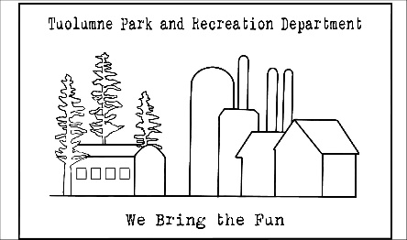

TUOLUMNE PARK AND RECREATION DISTRICT
ECONOMIC SERVICES CORPORATION

Agenda

Board of Directors Meeting
Wednesday, January 10, 2024
following TPRD meeting
Tuolumne Park and Recreation District Office

- Open Meeting

- Approval of Agenda

- Public Input-Items of interest not on the agenda (5 minutes limit each speaker)

- Correspondence

- Agenda Items

5.1 Mid-Fiscal Year Report

- Items for next Agenda

- Adjournment

TUOLUMNE PARK AND RECREATION DISTRICT
ECONOMIC SERVICES CORPORATION
18603 PINE STREET
TUOLUMNE, CA 95379
209.928-1214

Certification of Posting

I certify that on January 10, 2024 I posted a copy of the foregoing agenda near the regular meeting pace of the Board of Directors of Tuolumne Park and Recreation Economic Services Corporation, said time being at least 72 hours in advance of the meeting of the Board of Directors (Government Code Section 54954.2)

Executed at Tuolumne, California, on January 10, 2024.

_______________________________________
Tonia Misenti
District Secretary

